# CS 255 System Design Document Template

This template lays out all the different sections that you need to complete for Project Two. Each section has guidance to prompt your thinking. You will need to continually reference the interview transcript as you work to make sure that you are addressing your client’s needs. There is no required length for the final document. Instead the goal is to complete each section based on what your client’s needs are. Remove this note when you are finished, and replace all bracketed text with the relevant information.

## UML Diagrams

### UML Use Case Diagram

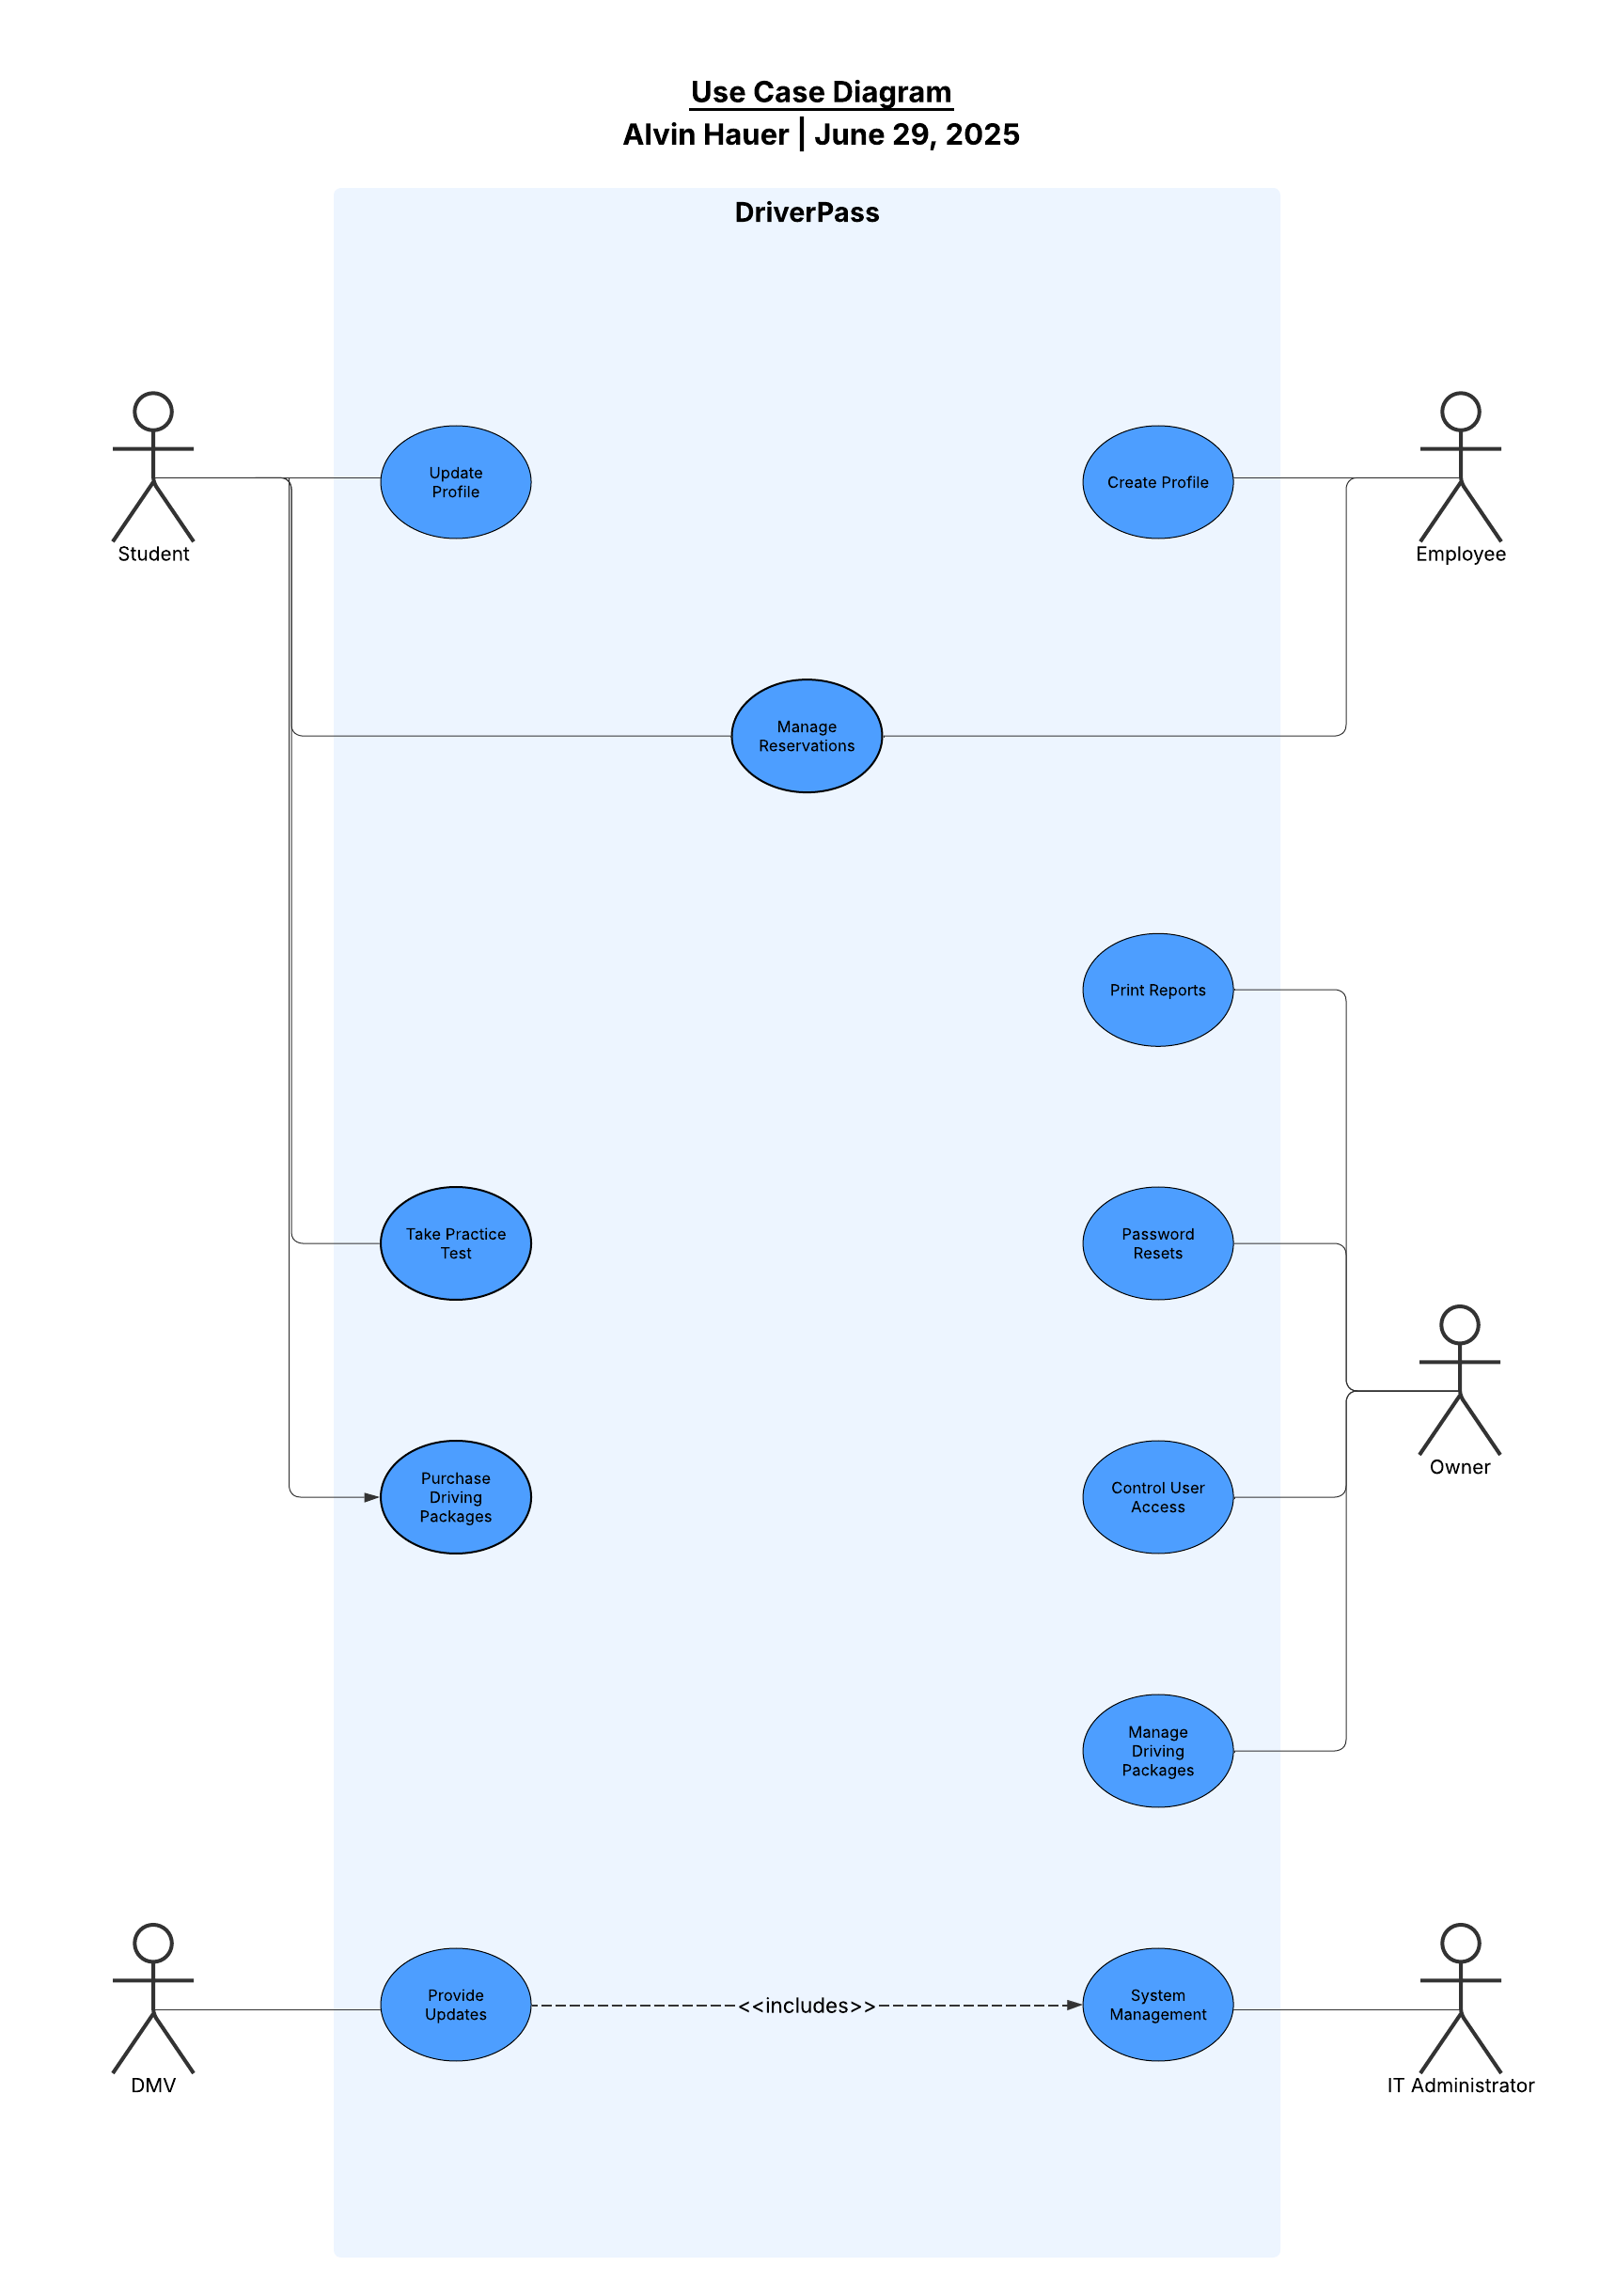

### UML Activity Diagrams

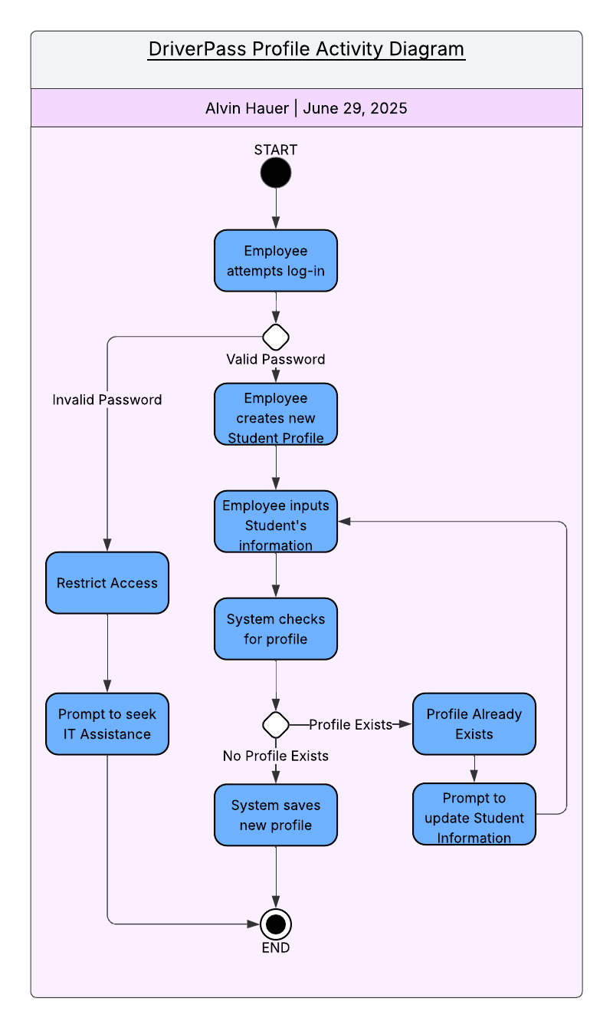

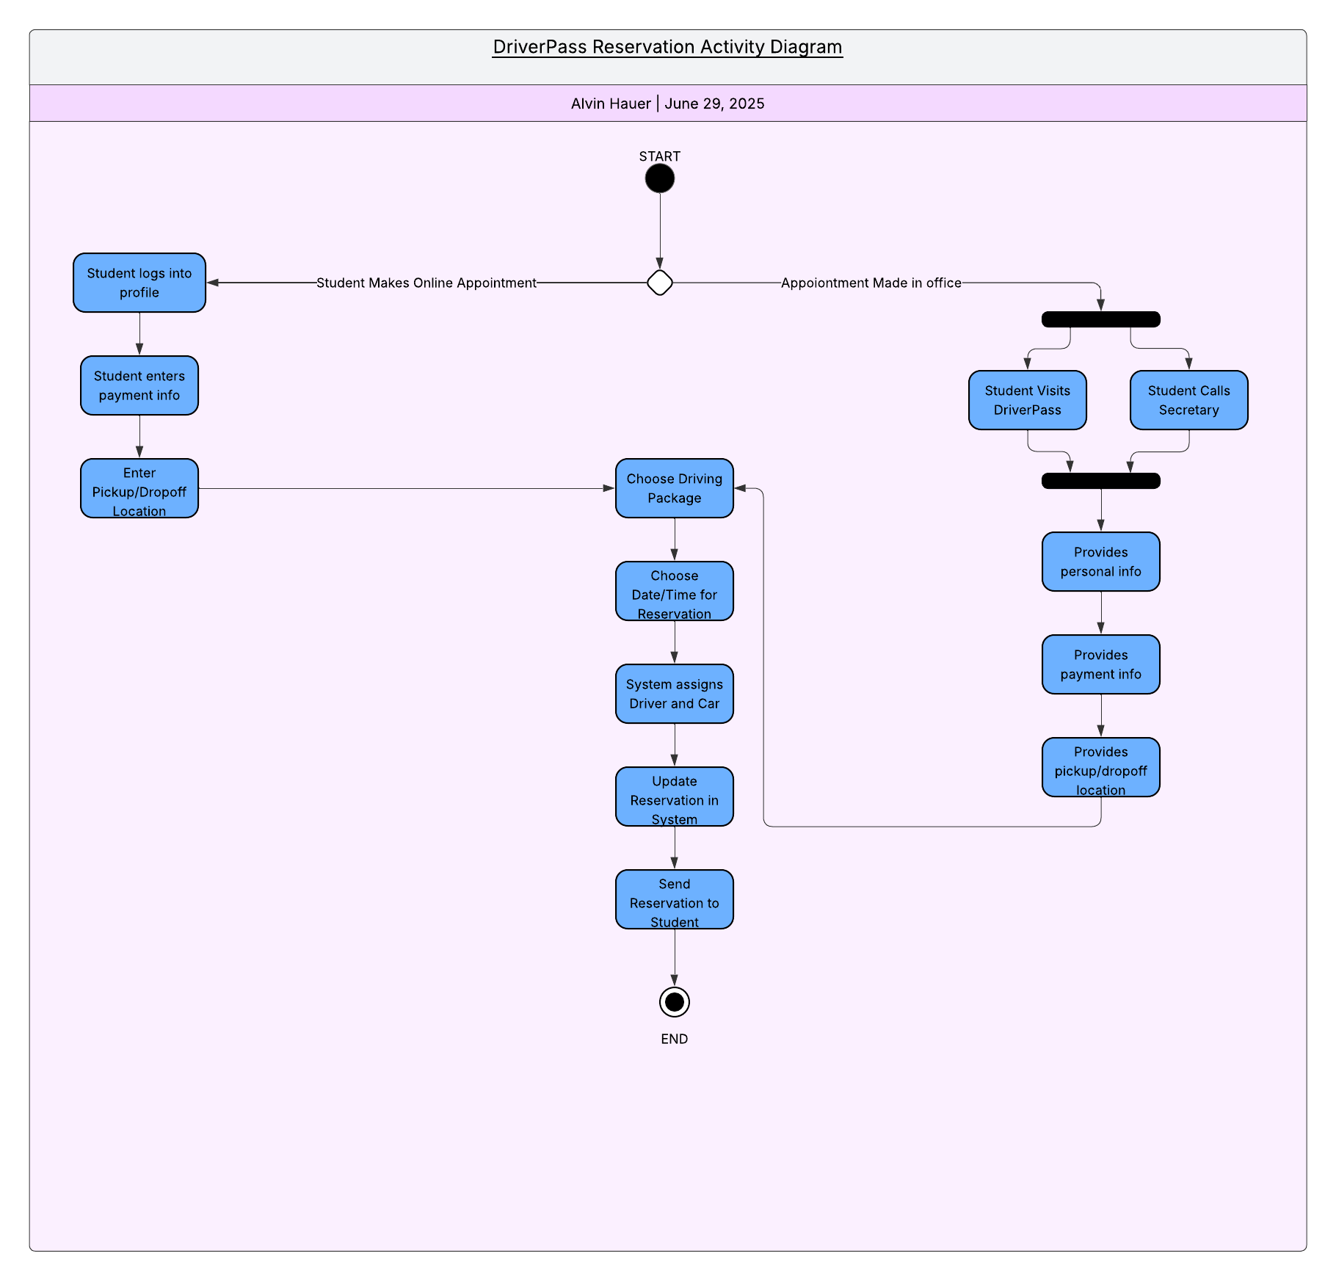

### UML Sequence Diagram

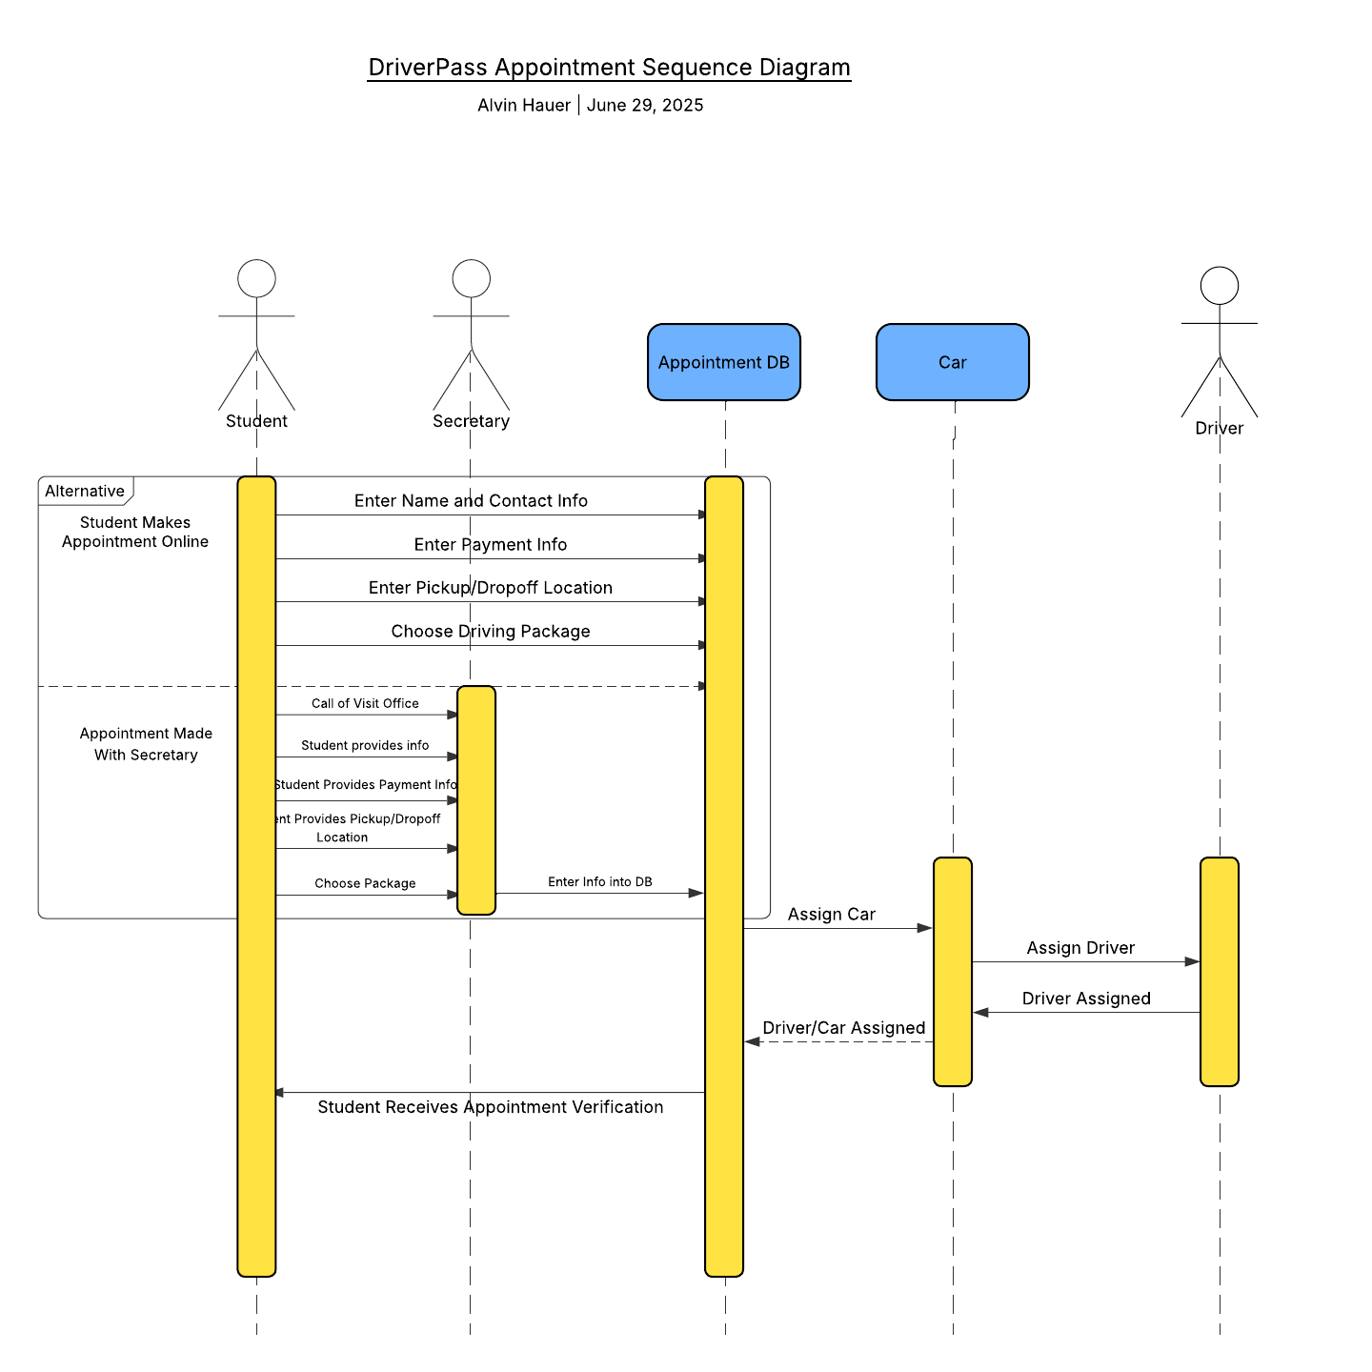

### UML Class Diagram

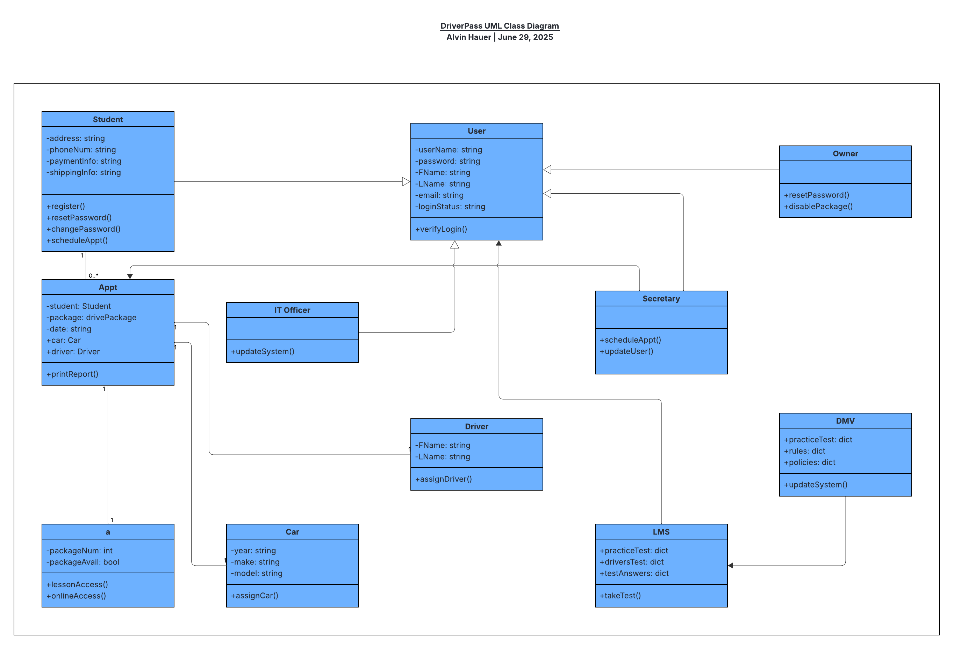

## Technical Requirements

DriverPass is looking to launch a new web-based application that will utilize cloud-based computing to manage data storage, schedule driving tests and online coaching, and maintain currency with DMV regulations and policies. DMV updates will be conducted automatically through synchronization of systems between local DMVs and DriverPass. Other technical requirements include payment processing software in order to process customer payments for various courses of instruction. Recommendation is to use Java as it is more robust and developer-friendly. Its also a more secure language which will help protect the system from malicious code attacks.